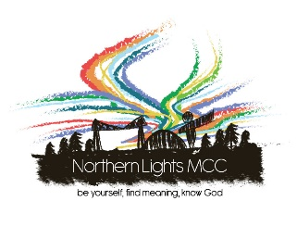

Nomination for Election to the

Board of Directors 2022

To be completed by the person nominating

I nominate …………………………….………for election to the Board of Northern Lights MCC

I am a Member in good standing of Northern Lights MCC.

(Signed) ……………………..…….Name (please print)……………..……………………………….

To be completed by the nominee
I accept the nomination for election to the Board of Northern Lights MCC and am willing to serve as a member of the Board and Church Trustee. I am a Member in good standing of Northern Lights MCC.

My gifts, skills and experience that would be useful on the Board are:

I wish to support Northern Lights MCC by serving on the Board because…..

(Signed) …………………………….…Name (please print) ………………………………..…….
Forms must reach the Assistant Church Secretary (Lily-Rose Lenton) not later than 10pm, Sunday 17th April 2022. If the Assistant Church Secretary is not available you may pass this to another Board Member. You may return your form electronically to laydelegate@northernlightsmcc.org.uk or in person. Both signatures must be shown. When submitting electronically, please CC your nominator in, in lieu of a physical signature.

